21.10: a) Rubbing the glass rod removes electrons from it, since it becomes positive.
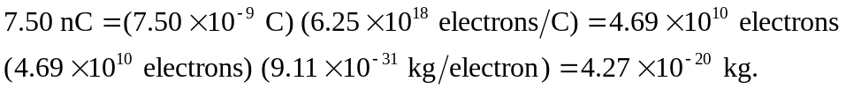
The rods mass decreases by 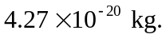
b) The number of electrons transferred is the same, but they are added to the mass of the
plastic rod, which increases by

